**Final Year Project Report**

**Project Name**



**Project Advisor:**

**Submitted By:**

**Session**

**University of Management and Technology**

**C-II Johar Town Lahore Pakistan**

**Dedication**

## 

**Final Approval**

* **Head of Department**  ______________________

Department of Artificial Intelligence

School of Systems & Technology

UMT Lahore

* **Director (Final Year Projects)** ______________________

Department of Artificial Intelligence

School of Systems & Technology

UMT Lahore

* **Supervisor** ______________________
* Department of Artificial Intelligence
* School of Systems & Technology

UMT Lahore

* **Co-Supervisor** ______________________

**Acknowledgment**

**Project Title**

**Objective**

**Undertaken by**

**Supervised by**

**Starting Date**

**Completion Date**

**Tools Used**

**Operating System**

**Documentation**

**Plagairism ReportAbstract**

Revision Chart

This chart contains a history of this document’s revisions. The entries below are provided solely for illustration purposes. Those entries should be deleted until the revision/s they refer to have actually been created.

The document itself should be stored in revision control, and a brief description of each version should be entered in the Revision Control System. A brief description can be repeated in this section. Revisions need not be described elsewhere in the document, unless they explain the document.

| Version | Primary Author(s) | Description of Version | Date Completed |
| --- | --- | --- | --- |
| *Draft* | TBD | Initial draft created for distribution and review comments | (To be decided) TBD |
| *Preliminary* | TBD | Second draft incorporating initial review comments, distributed for final review | TBD |
| *Final* | TBD | First complete draft, which is placed under change control | TBD |
| *Revision 1* | TBD | Revised draft, revised according to the change control process and maintained under change control | TBD |
| *Revision 2* | TBD | Revised draft, revised according to the change control process and maintained under change control | TBD |
| *Etc.* | TBD | TBD | TBD |

# Contents

*New paragraphs formatted as Heading 1, Heading 2, and Heading 3 will be added to the table automatically. To update this table of contents in Microsoft Word, put the cursor anywhere in the table and press F9. If you want the table to be easy to maintain, do not change it manually.*

Contents 1

Definitions and Acronyms 3

List of Figures 4

List of Tables 5

1. Introduction 6

1.1 Motivations 6

1.2 Project Overview 6

1.3 Problem Statement 6

1.4 Objectives 6

2. Domain Analysis 7

2.1 Customer 7

2.2 Stakeholders 7

2.3 Affected Groups with social or economic impact 7

2.4 Dependencies/ External Systems 7

2.5 Reference Documents 7

2.5.1 Related Projects 7

2.5.2 Feature Comparison 8

3. Requirements analysis 9

3.1 Requirements 9

3.2 List of Actors 10

3.3 List of use cases 10

3.4 System use case diagram 10

3.5 Extended use cases 10

3.6 User interfaces (mock screens) 12

4. Data flow diagram (optional) 13

4.1 Data Flow Diagram Level 0 13

4.2 Data Flow Diagram Level 1 13

4.3 Data Flow Diagram Level 2 13

5. System Design 15

5.1 System Architecture Diagram 15

5.2 Class Diagram 16

5.3 Collaboration Diagrams 17

5.4 Other UMLs 18

5.5 ERD 18

5.6 Data Dictionary 18

6. Implementation details 19

6.1 Development Setup 19

6.2 Deployment setup 19

6.3 Algorithms 19

6.4 Constraints 19

6.4.1 Assumptions 19

6.4.2 System constraints 19

6.4.3 Restrictions 19

6.4.4 Limitations 19

7. Testing 20

7.1 Extended Test Cases 20

7.2 Decision Table 20

7.2.1 Code snippet 20

7.2.2 Decision coverage table 20

7.3 Traceability Matrix 21

7.3.1 RID vs UCID (requirements vs use cases) 21

7.3.2 Prototypes (RID vs PID) 22

7.3.3 Test Cases (RID vs TID) 22

7.3.4 Coverage (UCID vs TID) 22

8. Results/Output/Statistics 23

8.1 %completion 23

8.2 %accuracy 23

8.3 %correctness 23

9. Conclusion 24

10. Future work 25

11. Bibliography 26

11.1 Books 26

11.2 Journals 26

11.3 Articles 26

11.4 Research papers 26

11.5 Other References 26

12. Appendix 27

12.1 Glossary of terms 27

12.2 Pre-requisites 27

## Definitions and Acronyms

*Provide definitions or references to all the definitions of the special terms and acronyms used within this document*

e.g

|  |  |
| --- | --- |
| **Acronym** | **Definition** |
| UMT | University of Management and Technology |
| POS | Point of Sale |

Table 1: table of acronyms and definitions

## List of Figures

New figures that are given captions will be added to the table automatically.

* **Insert caption:**
  1. select picture
  2. right click
  3. select “insert caption”
  4. under “options”, choose label as “figure”
  5. Under “caption”, an automatic insertion of “figure no” will appear. Give your figure an appropriate caption
* **Update list of figures:**To update this list in Microsoft Word, put the cursor anywhere in the table and press F9.
* **Note:**  If you want the table to be easy to maintain, do not change it manually.

Figure 1: sample use case diagram with explanation 10

Figure 2: System Architecture 15

## List of Tables

New Tables that are given captions will be added to the table automatically.

* **Insert caption:**
  1. select picture
  2. right click
  3. select “insert caption”
  4. under “options”, choose label as “table”
  5. Under “caption”, an automatic insertion of “table no” will appear. Give your table an appropriate caption
* **Update table:** To update this table of contents in Microsoft Word, put the cursor anywhere in the table and press F9.
* **Note:**  If you want the table to be easy to maintain, do not change it manually.

Table 1: table of acronyms and definitions 3

Table 2: list of stakeholders 7

# Introduction

*This section should describe the project and the software product being to be built. No text is necessary between the heading above and the heading below unless otherwise desired.*

## Motivations

Robotics is rapidly transforming how we interact with the world, especially in areas where human access is difficult or dangerous. The motivation behind this project, *RANGER - Robotic Autonomous Navigation for Geospatial Exploration & Reconnaissance*, stems from the need for an intelligent robotic system capable of navigating and mapping unknown environments independently. Applications in fields like search and rescue, warehouse automation, and environmental monitoring highlight the necessity of autonomous systems that can operate with minimal human intervention. The combination of real-time navigation and mapping offers both practical and life-saving advantages.

## Project Overview

RANGER is a robotic system designed to autonomously explore unfamiliar environments, generate real-time maps, avoid obstacles, and perform geospatial reconnaissance without human guidance. Using a suite of sensors including LIDAR, ultrasonic sensors, an IMU, and a night-vision camera, the robot gathers information about its surroundings. Powered by a Raspberry Pi and running on ROS (Robot Operating System), it uses SLAM algorithms like GMapping for real-time mapping and localization. Advanced path-planning algorithms, such as A*, enable the robot to make intelligent navigation decisions, ensuring efficient and safe exploration even in challenging terrains.

## Problem Statement

In various critical scenarios such as disaster-stricken areas, expansive warehouses, or remote environmental sites, the ability to autonomously navigate and map an unknown environment is essential. Traditional systems either rely heavily on human control or lack the intelligence to adapt to dynamic surroundings. There is a need for a cost-effective, robust, and fully autonomous mobile robot that can operate independently, accurately map its environment, and avoid obstacles in real-time.

## Objectives

* Develop a mobile robot capable of autonomous exploration and navigation.
* Implement real-time mapping using LIDAR and SLAM algorithms.
* Integrate obstacle detection and avoidance using ultrasonic sensors.
* Capture visual data in low-light conditions using a night-vision camera.
* Design intelligent path planning using the A* algorithm.
* Achieve stable real-time updates and data reporting during missions.

# Domain Analysis

## Customer

The primary beneficiaries of RANGER are industries requiring autonomous inspection and mapping solutions, search and rescue teams needing exploration support in hazardous areas, and research institutions focusing on robotics and autonomous navigation systems. Although the project currently does not have a contracted client, its design aligns closely with the needs of real-world applications in both the public and private sectors.

## Stakeholders

|  |  |
| --- | --- |
| **Stakeholder** | **Role in System** |
| **Project Developers** | **Responsible for designing, building, and programming the robot.** |
| **Researchers** | **Utilize RANGER for experimental and testing purposes.** |
| **Industrial Operators** | **Deploy the robot for warehouse and site exploration tasks.** |
| **Rescue Teams** | **Use RANGER in missions involving inaccessible or dangerous areas.** |

Table 2: list of stakeholders

## Affected Groups with social or economic impact

* **Rescue Organizations**: Enhanced safety by deploying robots instead of humans in dangerous missions.
* **Logistics and Warehouse Industries**: Improved efficiency and reduced human labor costs.
* **Research Community**: Advancement in autonomous navigation and mapping technologies.

## Dependencies/ External Systems

* **Robot Operating System (ROS)**: For robot communication and data processing.
* **GMapping SLAM Package**: For real-time simultaneous localization and mapping.
* **Hardware components** like LIDAR, ultrasonic sensors, IMU, night-vision camera, and Raspberry Pi are essential for system functionality.
* *A Algorithm Implementation*\*: For efficient path planning.

## Reference Documents

* ROS Documentation ([www.ros.org](http://www.ros.org))
* Research articles and tutorials on SLAM and autonomous navigation
* Previous projects involving robotic exploration and mapping
* Manufacturer datasheets for LIDAR, IMU, and ultrasonic sensors

### Related Projects

List of all the documents/ projects that you have looked up as reference material for this project along with their links/references. E.g

In order to develop UMTmanagementSystem, we looked up several similar systems. Their details are given below

1. FastManagementSystem(FMS)

Developed by XYZ. The partial documentation was obtained by the XYZ development team and the working of this management software was observed from abcFAST.com.pk

1. BeaconHouse Management System (BHMS)

Developed by ABC. the working of this management software was observed from abcbeaconhouse.com.pk. no relevant documentation was available.

1. “constructing and ideal academic system” (CIAS)

Research paper published by IEEE. The research paper is not available for free. It is only available to IEEE members

### Feature Comparison

|  |  |  |  |  |  |
| --- | --- | --- | --- | --- | --- |
| Sr No. | Comparison Feature | FMS | BHMS | CIAS | remarks |
| 1 | ABC | FMS covers the feature ABC completely as desired | BHMS does not support feature ABC | CIAS suggests that maximum efficiency can be achieved if ABC is implemented using algorithm abc. | Using the ABC feature from FMS and improving it with abc algorithm can provide maximum efficiency |

# Requirements analysis

## Requirements

The RANGER system has the following requirements categorized into functional, non-functional, data, constraints, and external interface requirements:

Functional Requirements

| **RID** | **Description** | **Category** | **Attribute** | **Details & Boundary Constraints** |
| --- | --- | --- | --- | --- |
| FR1 | The system shall autonomously navigate in unknown environments. | Functional | Navigation | Must operate without human intervention. |
| FR2 | The system shall generate real-time maps using LIDAR and SLAM algorithms. | Functional | Mapping | Maps must update at least once per second. |
| FR3 | The system shall detect and avoid obstacles using ultrasonic sensors. | Functional | Obstacle Avoidance | Detection range: 2cm to 400cm. |
| FR4 | The system shall capture visual data in low-light conditions. | Functional | Imaging | Night-vision camera resolution: 720p minimum. |
| FR5 | The system shall plan paths using the A* algorithm. | Functional | Path Planning | Path re-planning time: < 500ms. |

Non-Functional Requirements

| **RID** | **Description** | **Category** | **Attribute** | **Details & Boundary Constraints** |
| --- | --- | --- | --- | --- |
| NFR1 | The system shall respond to sensor inputs within 100ms. | Non-Functional | Response Time | Critical for real-time operation. |
| NFR2 | The system shall operate continuously for at least 4 hours. | Non-Functional | Battery Life | Using rechargeable Li-ion battery. |
| NFR3 | The system shall weigh less than 5kg for portability. | Non-Functional | Weight | Includes all sensors and components. |

Data Requirements

| **RID** | **Description** | **Category** | **Attribute** | **Details & Boundary Constraints** |
| --- | --- | --- | --- | --- |
| DR1 | The system shall store map data in a ROS-compatible format. | Data | Storage | Maps must be exportable for analysis. |
| DR2 | The system shall log sensor data for debugging. | Data | Logging | Logs must be timestamped and labeled. |

Constraints

| **RID** | **Description** | **Category** | **Attribute** | **Details & Boundary Constraints** |
| --- | --- | --- | --- | --- |
| C1 | The system shall use ROS for communication and data processing. | Constraint | Software | Must integrate with ROS Noetic. |
| C2 | The system shall be powered by a Raspberry Pi 4. | Constraint | Hardware | Minimum 4GB RAM required. |

External Interface Requirements

| **RID** | **Description** | **Category** | **Attribute** | **Details & Boundary Constraints** |
| --- | --- | --- | --- | --- |
| EIR1 | The system shall interface with LIDAR (RPLIDAR A1). | External Interface | Hardware | Baud rate: 115200. |
| EIR2 | The system shall support remote monitoring via Wi-Fi. | External Interface | Communication | Range: up to 50m indoors. |

## List of Actors

1. **Project Developers**:

Design, build, and program the robot.

1. **Researchers**:

Utilize RANGER for experimental purposes.

1. **Industrial Operators**:

Deploy the robot for warehouse tasks.

1. **Rescue Teams**:

Use RANGER in hazardous areas.

## List of use cases

1. **UC1:**

**Autonomous Navigation** – Robot navigates without human input.

1. **UC2:**

**Real-Time Mapping** – Robot generates and updates maps.

1. **UC3:**

**Obstacle Avoidance** – Robot detects and avoids obstacles.

1. **UC4:**

**Low-Light Imaging** – Robot captures images in dark environments.

1. **UC5:**

**Path Planning** – Robot calculates optimal paths using A*.

## System use case diagram

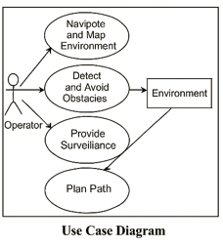

Figure 1: sample use case diagram with explanation

## Extended use cases

UC1: Autonomous Navigation

| **Use Case ID:** | **UC1** |
| --- | --- |
| **Use Case Name:** | Autonomous Navigation |
| **Actors:** | Project Developers, Industrial Operators, Rescue Teams |
| **Description:** | The robot navigates an unknown environment without human input. |
| **Preconditions:** | 1. Sensors (LIDAR, IMU) are calibrated. 2. ROS is operational. |
| **Postconditions:** | Robot reaches target location or reports failure. |
| **Normal Flow:** | 1. Robot scans environment. 2. Updates map. 3. Moves to target. |
| **Exceptions:** | 1. Sensor failure: Switch to backup sensors. 2. Stuck: Re-plan path. |

UC2: Real-Time Mapping

| **Use Case ID:** | **UC2** |
| --- | --- |
| **Use Case Name:** | Real-Time Mapping |
| **Actors:** | Researchers, Industrial Operators |
| **Description:** | Robot generates and updates maps using LIDAR and SLAM. |
| **Preconditions:** | 1. LIDAR is functional. 2. GMapping SLAM is installed. |
| **Postconditions:** | Map is saved or transmitted to the user. |
| **Normal Flow:** | 1. LIDAR scans environment. 2. SLAM updates map. 3. Map is saved. |

## User interfaces (mock screens)

Initial mockup screens (even hand drawn drafts) will be inserted here. Each screen will be given an appropriate prototype id.e.g.

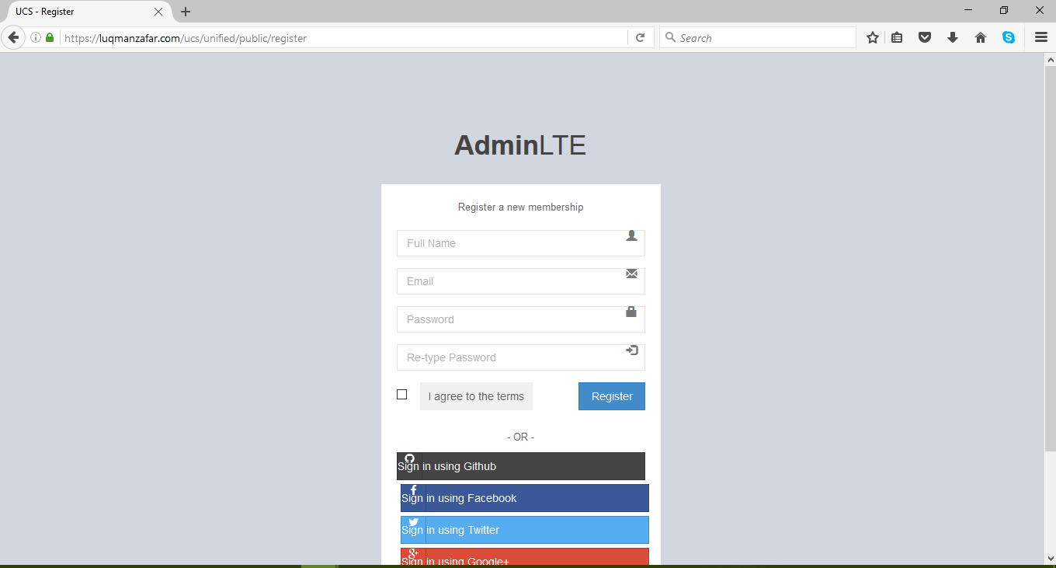

Prototype1: (P1) register a new member

# Data flow diagram (optional)

## Data Flow Diagram Level 0

The Level 0 Data Flow Diagram (DFD) provides a high-level overview of the R.A.N.G.E.R. system, illustrating the major external entities and the primary data interactions between them and the core system. It abstracts away internal processes to highlight how data flows into and out of the RANGER platform.

In this context, RANGER is treated as a single, unified process that interacts with multiple external actors, including the Operator (user), Cloud Services (for updates or remote logging), the Environment (via sensors), and Control Interfaces. The DFD helps clarify how data is exchanged, ensuring a clear understanding of system boundaries and external communications.

**External Entities:**

* **Operator** – Sends navigation commands and receives telemetry/status updates.
* **Environment** – Provides real-world inputs through sensors such as LIDAR, camera, and ultrasonic modules.
* **Cloud Services** – Optional external servers for logging data, receiving software updates, or AI model enhancements.
* **Control Interfaces** – Interfaces like mobile apps or GUI for real-time control and visualization.

**Processes (as a black box):**

* **RANGER System** – Receives commands, processes sensor data, and outputs decisions and responses.

**Data Stores:**  
Level 0 does not typically depict data stores, focusing only on high-level interactions.

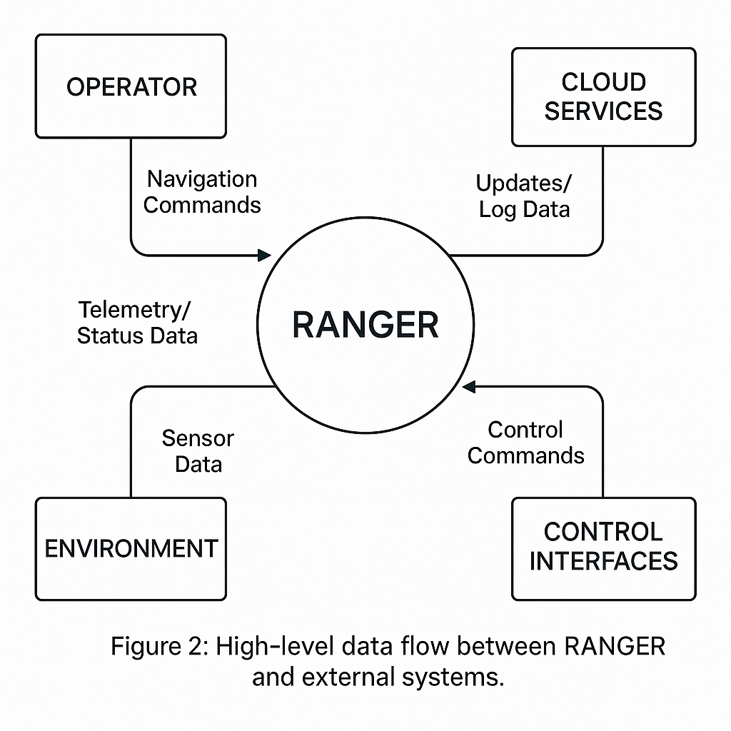

## Data Flow Diagram Level 1

The Level 1 Data Flow Diagram provides a detailed breakdown of the internal processes of the R.A.N.G.E.R. system. Unlike the Level 0 DFD, which treats the system as a single process, this diagram decomposes the RANGER system into major subsystems that handle specific tasks such as perception, decision-making, actuation, and communication.

**Key Internal Processes:**

* **Sensor Interface** – Gathers data from ultrasonic sensors, LIDAR, camera, and IMU.
* **Perception Module** – Processes raw sensor data to construct a spatial understanding of the environment.
* **Navigation & Path Planning** – Calculates optimal paths and avoidance strategies using SLAM and mapping data.
* **Motor Control System** – Executes movement commands based on navigation outputs.
* **Communication Interface** – Manages data exchange with external entities (Operator, Cloud Services, Control Interfaces).
* **System Monitor** – Collects telemetry data and handles feedback loops for health/status reporting.

**Data Stores (optional in DFD Level 1):**

* **Map/SLAM Data** – Stores real-time maps and localization data.
* **Command Queue** – Holds incoming and scheduled commands.
* **Sensor Logs** – Stores historical data for diagnostics or ML training.

This diagram aids in understanding how internal modules interact and the flow of data through different system layers.

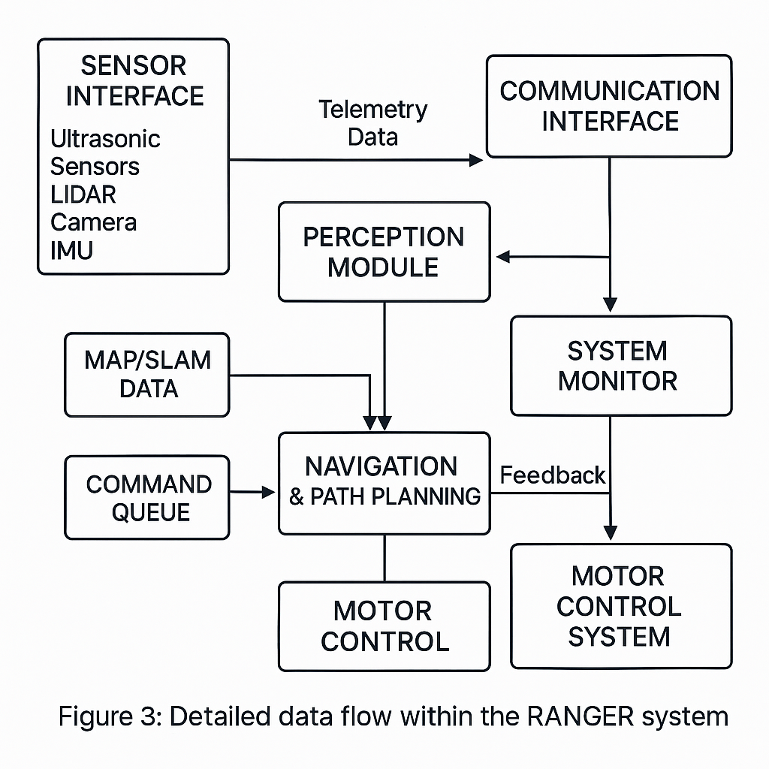

## Data Flow Diagram Level 2

The Level 2 Data Flow Diagram provides an in-depth view of the internal workings of the **SLAM (Simultaneous Localization and Mapping)** and **Path-Planning** subsystems within the R.A.N.G.E.R. architecture. These modules are critical for enabling autonomous navigation in unknown environments.

**Key Components:**

* **Sensor Data Inputs**:
  + LIDAR
  + IMU
  + Camera
  + Odometry (wheel encoders)
* **SLAM Processor**:
  + Fuses sensor data to build and update a real-time map.
  + Continuously estimates RANGER's position relative to the environment.
* **Map Database**:
  + Stores the updated occupancy grid or feature-based map.
  + Used for global and local planning.
* **Localization Engine**:
  + Matches real-time sensor data with the existing map to improve position estimates.
  + Feeds accurate pose data to the Path-Planning module.
* **Path-Planning Engine**:
  + Receives the robot’s current pose and goal location.
  + Generates safe, efficient paths using algorithms such as A*, Dijkstra, or RRT.
  + Avoids dynamic obstacles and updates in real-time.
* **Motion Command Output**:
  + Translates planned paths into motor commands.
  + Passed to the Motor Control subsystem for execution.

This diagram illustrates the logical flow of sensor fusion, mapping, and decision-making, demonstrating the intelligence behind autonomous movement.

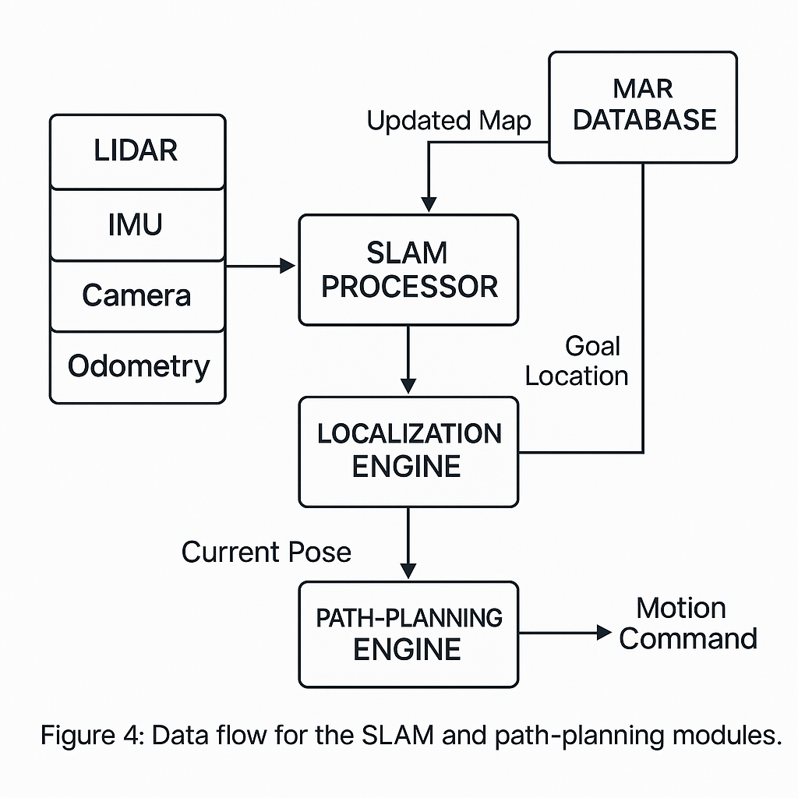

# System Design

Describe the system architecture, or simply provide the architecture diagram. For School system it may include web based front end, webserve , database etc. Don’t worry too much about it just give a simple diagram of a typical web based project.

## System Architecture Diagram

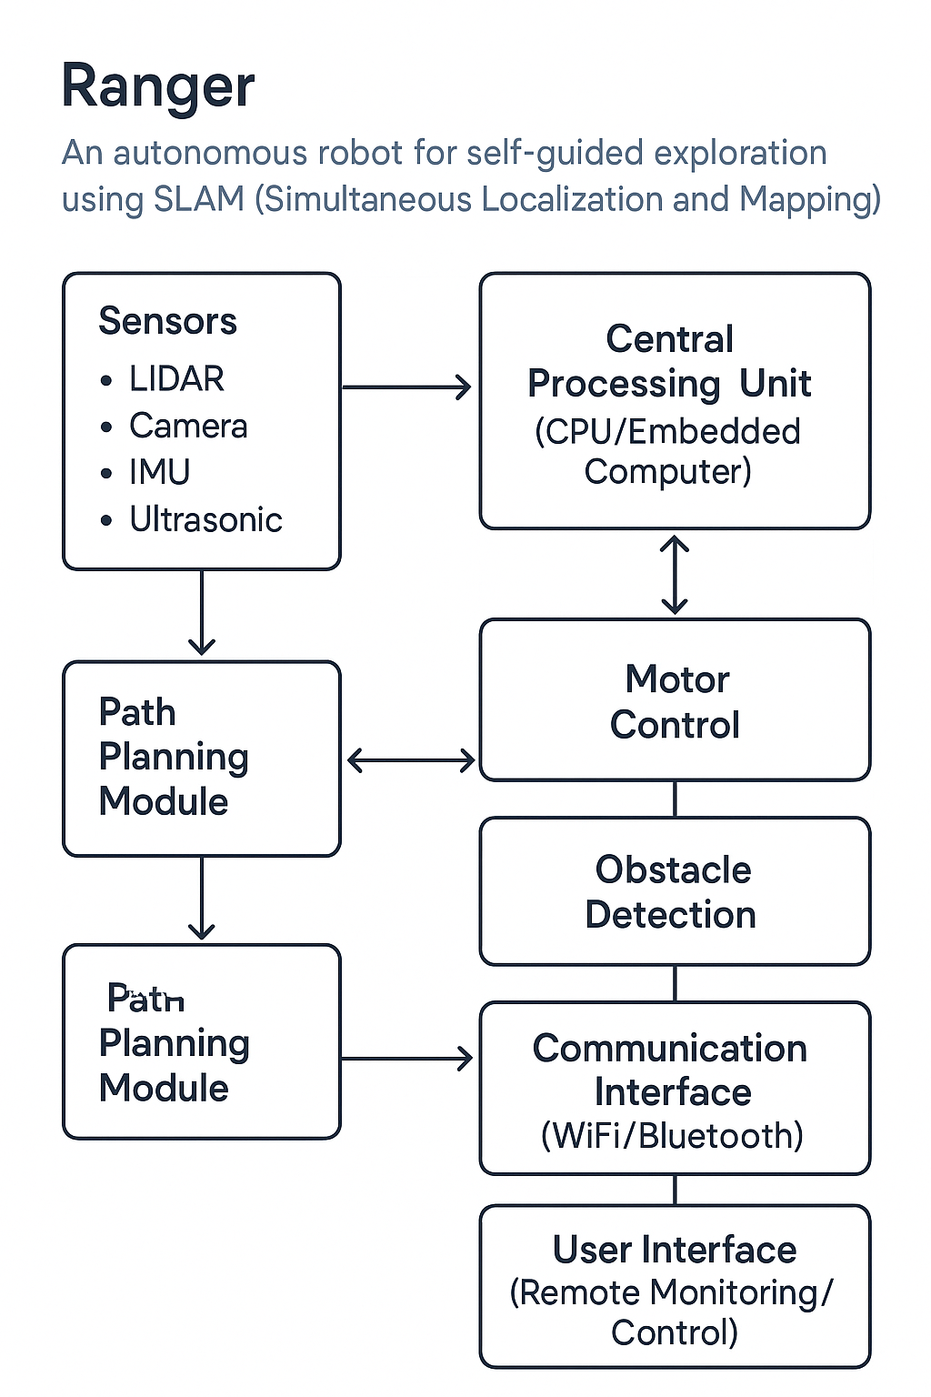

Figure 2: System Architecture

## Class Diagram

## 

## Sequence Diagrams

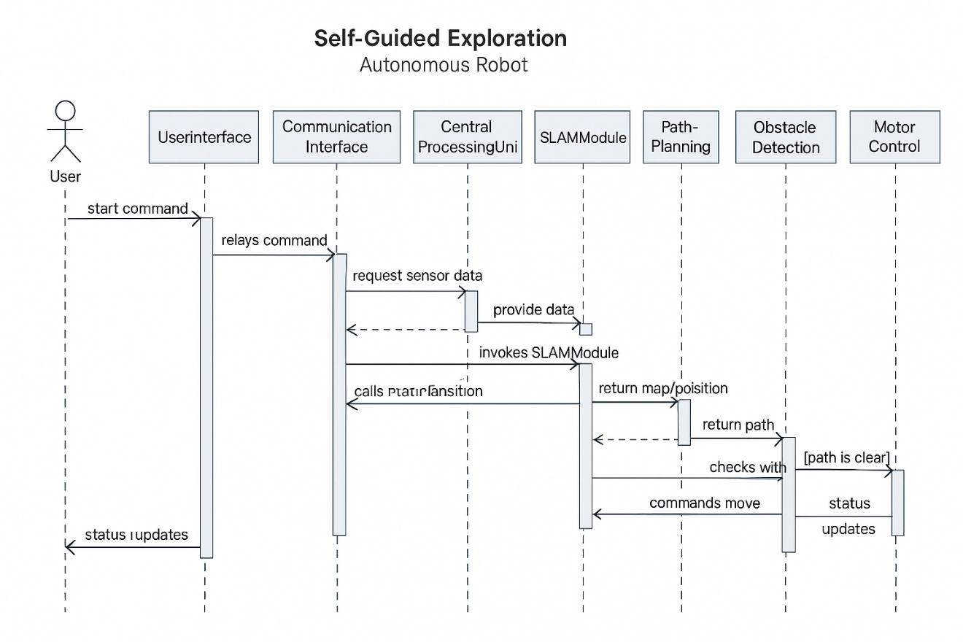

## Collaboration Diagrams

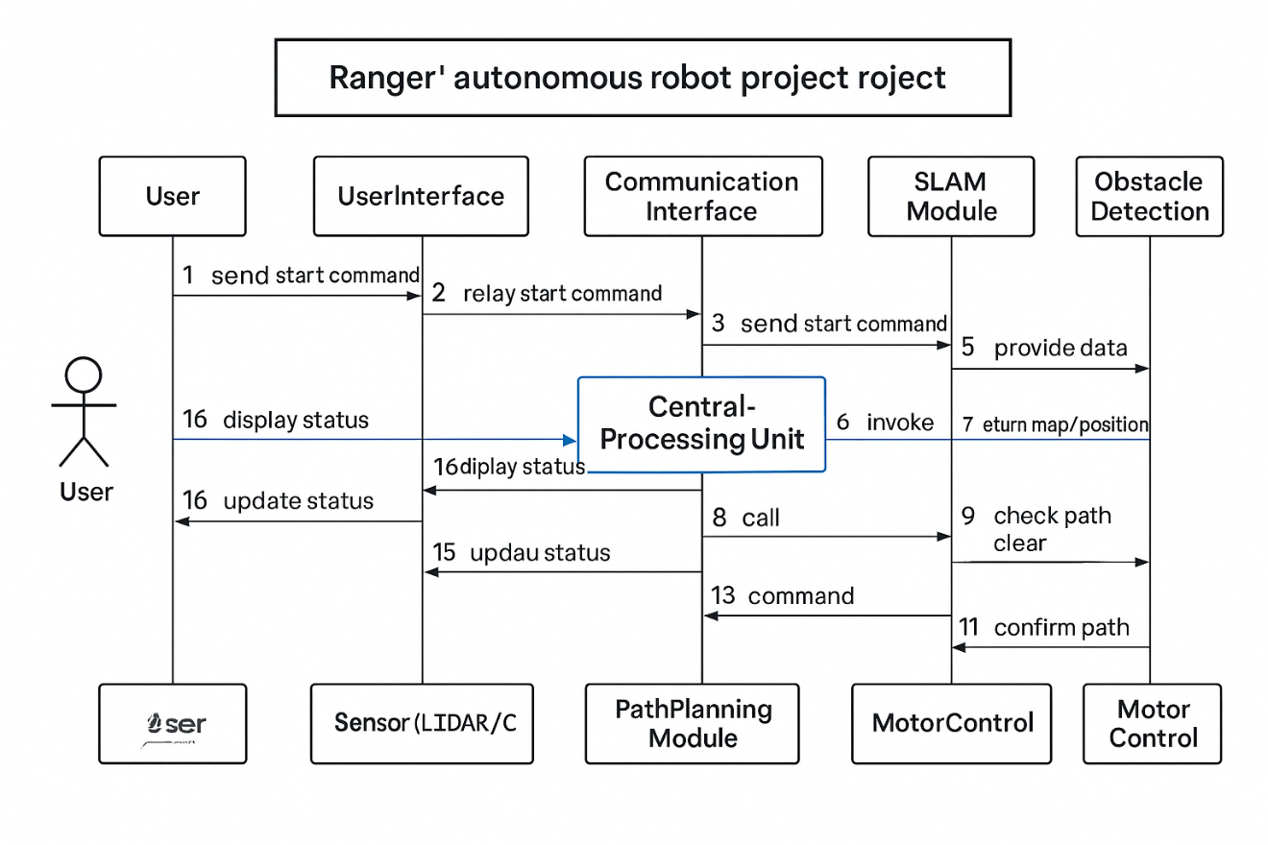

## Other UMLs

This is optional. You may include any other UML to support your system.

## ERD

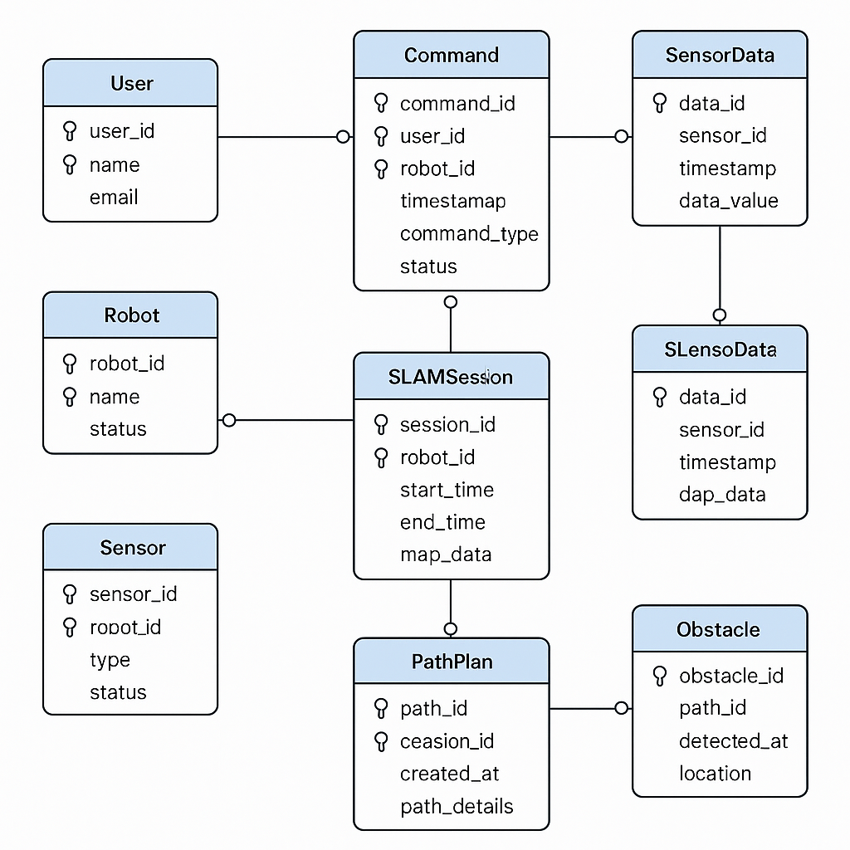

## Data Dictionary

This section may be used to provide the details of interface elements that are present on the screenshots.

|  |  |  |  |  |
| --- | --- | --- | --- | --- |
| Element Name | Type | Validation | Mandatory | Remarks |
| |  | | --- | | LIDAR Data |  |  |  |  |  |  |  |  |  | | --- | --- | --- | --- | --- | --- | --- | --- | | Ultrasonic Distance   |  |  |  |  |  |  | | --- | --- | --- | --- | --- | --- | | IMU Acceleration   |  | | --- | | Map Grid | | |  | | --- | | Camera Feed |  |  | | --- | |  | |  |  | | --- | |  | |  |  | | --- | |  | |  |  | | --- | |  | | |  | | --- | | Float Array |  |  |  |  | | --- | --- | --- | | |  | | --- | | Float |  |  | | --- | |  | | | Vector3 | | | |  | | --- | | 2D Array |  |  | | --- | |  | | |  |  | | --- | |  | | Image Frame | |  |  | | --- | |  | | |  | | --- | | Range limited |  |  |  |  | | --- | --- | --- | | |  | | --- | | < 4 meters |  |  | | --- | |  | | | Normalized values | |  |  | | --- | |  | | Occupancy values   |  | | --- | | Grayscale/Night mode |  |  | | --- | |  | | |  |  | | --- | |  | | Yes  Yes  Yes  Yes   |  | | --- | | Optional |  |  | | --- | |  | | |  |  |  |  |  |  |  |  |  | | --- | --- | --- | --- | --- | --- | --- | --- | --- | | Used for mapping   |  |  |  |  |  | | --- | --- | --- | --- | --- | | Obstacle avoidance   |  |  |  | | --- | --- | --- | | Orientation and balance   |  | | --- | | SLAM output  Used for image/video capture |  |  | | --- | |  | |  |  | | --- | |  | |  |  | | --- | |  | | | | | |  |  |  | | --- | --- | --- | | |  | | --- | |  |  |  | | --- | |  | |  |  | | --- | |  | | |  | |  |  | | --- | |  |  |  | | --- | |  | |

# Implementation details

## Development Setup

The development environment for RANGER was built using open-source tools and readily available hardware components. The entire software stack runs on a **Raspberry Pi 4 Model B** with **4 GB RAM**, using **Ubuntu 20.04 LTS** with **ROS Noetic** installed.

**Key Tools & Libraries Used:**

* **ROS Noetic**: For robotics communication and modular design
* **Python 3 / C++**: Core programming languages for logic and sensor interfacing
* **GMapping**: ROS package for 2D SLAM
* **RViz**: Visualization tool for sensor data and map generation
* **Arduino IDE**: For microcontroller firmware (e.g., motor control)
* **OpenCV**: For image processing with the night-vision camera

## Deployment setup

The robot was deployed in indoor and semi-structured outdoor environments. Key components were mounted securely on a chassis, and batteries were used to power both Raspberry Pi and motor drivers. ROS nodes were launched via a custom launch file which initialized:

* LIDAR node for continuous scanning
* IMU for orientation feedback
* Ultrasonic node for obstacle detection
* GMapping node for SLAM
* Path planner for real-time navigation

Testing was conducted in:

* Lab corridors with variable lighting
* Simulated obstacle courses
* Dim or low-light environments for camera evaluation

Challenges such as uneven ground and sensor noise were addressed by calibrating filters and tuning SLAM parameters.

## Algorithms

#### ****SLAM (Simultaneous Localization and Mapping)****

Implemented using **GMapping**, this algorithm builds a 2D occupancy grid map while localizing the robot within it. LIDAR scans are matched over time to maintain map consistency.

#### A Path Planning*

This algorithm finds the shortest path from the robot’s current location to a given goal on the grid map. It uses cost functions and heuristics to avoid obstacles and minimize travel time.

#### ****Obstacle Avoidance Logic****

* **Ultrasonic Sensors** provide quick proximity feedback.
* If the distance to an object falls below a threshold, the robot halts or reroutes.
* A priority-based decision tree is used for maneuvering in tight spaces.

#### ****Camera Image Capture****

Using OpenCV and a night-vision module, images are periodically saved or streamed to assist in visual inspection during missions.

## Constraints

### Assumptions

• ROS packages used are stable and compatible with Raspberry Pi.

• Sensors are properly calibrated before deployment.

• The test area has sufficient contrast and features for SLAM to perform effectively.

• Power supply will last for at least 30 minutes of continuous operation.

### System constraints

• Raspberry Pi has limited processing power; heavy real-time image processing is minimized.

• Wi-Fi connectivity is required for remote monitoring unless working in fully autonomous mode.

• Limited storage capacity restricts long-term map logging and high-resolution video storage

### Restrictions

• Robot cannot climb stairs or handle very rough terrain.

• Operation limited to indoor and smooth outdoor surfaces.

• Battery recharge required after each testing cycle.

### Limitations

• Mapping accuracy may decrease in very dark environments or highly reflective surfaces.

• Minor lag in obstacle avoidance due to ultrasonic sensor polling delays.

• Visual recognition is not implemented (no object detection/classification).

# Testing

## Extended Test Cases

## 

## Decision Table

### Code snippet

### Decision coverage table

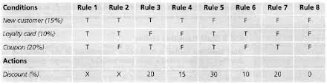

## Traceability Matrix

### RID vs UCID (requirements vs use cases)

|  |  |  |  |  |  |  |  |  |  |  |  |  |  |  |  |  |  |  |  |  |  |
| --- | --- | --- | --- | --- | --- | --- | --- | --- | --- | --- | --- | --- | --- | --- | --- | --- | --- | --- | --- | --- | --- |
| **UCID/RID** | **R**  **1** | **R**  **2** | **R**  **3** | **R**  **4** | **R**  **5** | **R**  **6** | **R**  **7** | **R**  **8** | **R**  **9** | **R**  **10** | **R**  **11** | **R**  **12** | **R**  **13** | **R**  **14** | **R**  **15** | **R**  **16** | **R**  **17** | **R**  **18** | **R**  **19** | **R**  **20** | **R**  **21** |
| UC 1 | ✓ | ✓ |  |  |  |  |  |  |  |  |  |  |  |  |  |  |  |  |  |  |  |
| UC 2 |  | ✓ |  |  |  |  |  |  |  |  |  |  |  |  |  |  |  |  |  |  |  |
| UC 3 | ✓ | ✓ |  |  |  |  |  |  |  |  |  |  | ✓ |  |  |  |  |  |  |  |  |
| UC 4 | ✓ | ✓ |  |  |  |  |  |  |  |  |  |  |  | ✓ |  |  |  |  |  |  |  |
| UC 5 | ✓ | ✓ | ✓ |  | ✓ |  |  |  |  |  |  |  |  |  |  |  |  |  |  |  |  |
| UC 6 | ✓ | ✓ |  | ✓ |  | ✓ |  |  |  |  |  |  |  |  |  |  |  |  |  |  |  |
| UC 7 | ✓ | ✓ | ✓ |  |  |  |  |  | ✓ |  |  |  |  |  |  |  |  |  |  |  |  |
| UC 8 | ✓ | ✓ |  | ✓ |  |  |  |  |  | ✓ |  |  |  |  |  |  |  |  |  |  |  |
| UC 9 | ✓ | ✓ | ✓ |  | ✓ |  |  |  |  |  | ✓ |  |  |  |  |  |  |  |  |  |  |
| UC 10 | ✓ | ✓ |  | ✓ |  | ✓ |  |  |  |  |  | ✓ |  |  |  |  |  |  |  |  |  |
| UC 11 | ✓ | ✓ | ✓ |  | ✓ |  | ✓ |  |  |  |  |  |  |  |  |  |  |  |  |  |  |
| UC 12 | ✓ | ✓ |  | ✓ |  | ✓ |  | ✓ |  |  |  |  |  |  |  |  |  |  |  |  |  |
| UC 19 | ✓ | ✓ | ✓ |  | ✓ |  |  |  |  |  |  |  |  |  | ✓ |  |  |  |  |  |  |
| UC 20 | ✓ | ✓ |  | ✓ |  | ✓ |  |  |  |  |  |  |  |  |  | ✓ |  |  |  |  |  |
| UC 21 | ✓ | ✓ | ✓ |  |  |  |  |  |  |  |  |  |  |  |  |  |  |  |  |  |  |
| UC 22 | ✓ | ✓ |  | ✓ |  |  |  |  |  |  |  |  |  |  |  |  |  |  |  |  |  |
| UC 23 | ✓ | ✓ | ✓ |  |  |  |  |  |  |  |  |  |  |  |  |  | ✓ |  |  |  |  |
| UC 24 | ✓ | ✓ |  | ✓ |  |  |  |  |  |  |  |  |  |  |  |  |  | ✓ |  |  |  |
| UC 25 | ✓ | ✓ | ✓ | ✓ |  |  |  |  |  |  |  |  |  |  |  |  |  |  | ✓ |  |  |
| UC 26 | ✓ | ✓ | ✓ | ✓ |  |  |  |  |  |  |  |  |  |  |  |  |  |  |  | ✓ |  |
| UC 27 | ✓ | ✓ | ✓ | ✓ |  |  |  |  |  |  |  |  |  |  |  |  |  |  |  |  | ✓ |

### Prototypes (RID vs PID)

### Test Cases (RID vs TID)

### Coverage (UCID vs TID)

# Results/Output/Statistics

## %completion

Use the matrix & values from 7.3.1 to show that all requirements are being fulfilled.

## %accuracy

Use the matrix & values from 7.3.3 to show that all requirements have been implemented correctly.

## %correctness

Use the matrix & values from 7.3.4 to show that all requirements have been tested to be conforming to requirements.

# Conclusion

# Future work

# Bibliography

Use IEEE or ACM format for citations

## Books

## Journals

## Articles

## Research papers

## Other References

# Appendix

## Glossary of terms

## Pre-requisites

Must use contents of development/ deployment setup & external system dependencies